COURSES WORKBOOK

Partnering Foundations

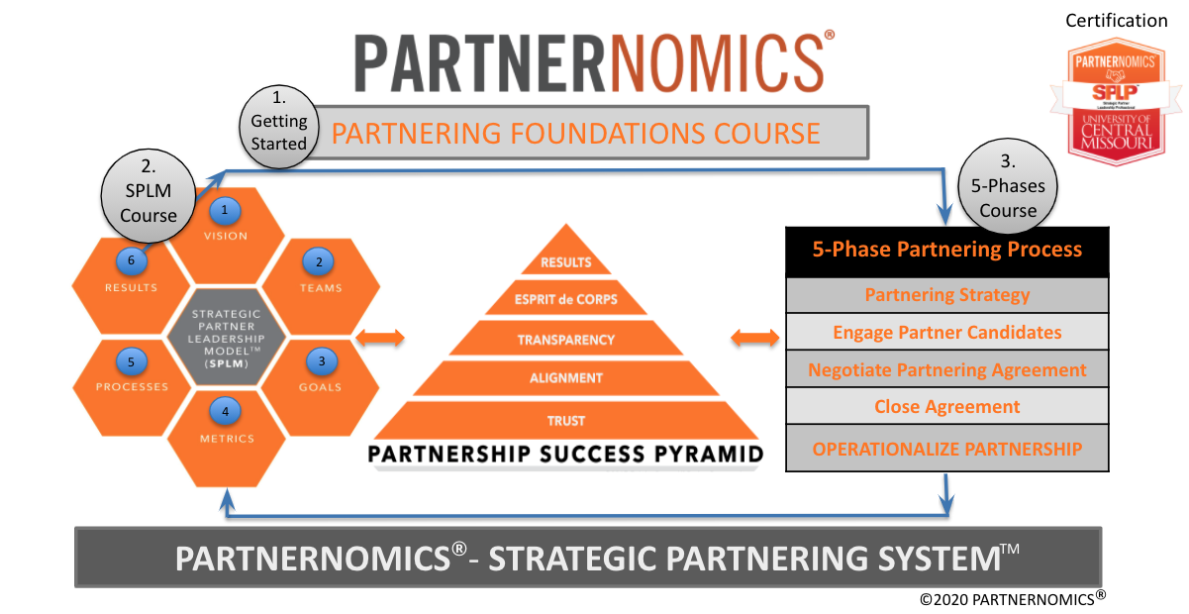
PARTNERING FOUNDATIONS

Course Description:
The PARTNERNOMICS – Partnering Foundations course is the first course in the recommended three-course sequence. This course is designed for business professionals who are interested in understanding the foundational components of developing long-term strategic partnerships with complementary organizations. The course explores the essential terms, concepts, processes, and strategies that leaders can utilize to generate profit growth through successful partnerships. The bulk of the content is focused on pre-contract signature activities and the successful practices that leaders should know and implement. At the successful completion of this course, participants will have a newly found appreciation for the value that partnerships can bring to organizations as well as understanding the major contributors to long-term partnership success.

This course is organized into a 6-week curriculum; however, participants are encouraged to complete the coursework at their own pace (100% self-paced). The course contains over 6 hours of video content, approximately half of the contents are topical lessons that explain key concepts, tools, processes, and strategies while the remaining includes expert interviews with international partnering and business growth thought-leaders.

Course Learning Objectives:
- Analyze the three core approaches for organizational value creation.
- Describe the five general types of partnerships.
- Evaluate opportunities to apply the 12 categories of partnership opportunities to the needs of your organization.
- Compare and contrast the pros and cons of the three core approaches for organizational value creation.
- Articulate the various components of the Business Growth Flowchart.
- Utilize the Business Growth Flowchart and the concepts from this course to create an organizational growth plan.

Week #1

Week #1 Learning Objectives:
- Participants will gain an appreciation for the significant value that partnerships can bring to organizations.
- Participants will learn the continuum of various partnerships (transactional versus highly collaborative).
- Participants will be able to explain how partnerships are impacted by the following frameworks: Quadrants of Solutions, Supply & Demand, and Goals for Partnerships.
- Participants will understand the 12 Opportunities for partnerships and be able to evaluate the potential value for each to their organization.

Topics in Video #1

- Intro to PARTNERNOMICS
- Story of Instagram
- Biz Case for Partnering

Questions to Consider:
- What makes a “strategic partnership” unique from other partnerships?
- What are the three avenues an organization can take to grow value and how does your organization consider each with new growth initiatives?
- Why has the total quantity of “partnership professionals” increased over the past 5 years?
- What is the expected success rate of 3rd party partnerships at the 2-year (post signature) mark and how can your organization improve your success rate?

Notes:

Thought Leader Interview
Bernie Brenner - Cofounder of TrueCar

Questions to Consider:
- What was your key takeaway from the Bernie Brenner video?
- How did TrueCar use technology to revolutionize the car buying experience?
- Does your executive team have a clear understanding of how the Biz Dev / strategic partnering function is different from sales?
- What is a “Sumo Advantage” and have you ever created one?
- Towards the end of the interview, Bernie said the single most important way to improve partnership success is to use and properly manage the Term Sheet. Do you agree with his philosophy?

Notes:

Topics in Video #2 & 2b
- Level set on job roles
- “Vendor” vs. “Partner”
- Transactional vs. Collaborative
- MSA vs Partnering Agreements
- “Complete” vs. “Incomplete” Contracts
- Partnering Mindset
- Role of Commitment

Questions to Consider:
- What are the mindset traits of a great strategic partnerships leader?
- How does the role of a supply chain manager differ from the role of a strategic partnerships leader?
- What is meant by “zero sum thinking” and is this a good approach for partnership professionals?
- Partnerships fall on a continuum between “transactional” and “highly collaborative/strategic.” What characteristics, such as “commitment,” differ between the ends of the partnering spectrum?

Notes:

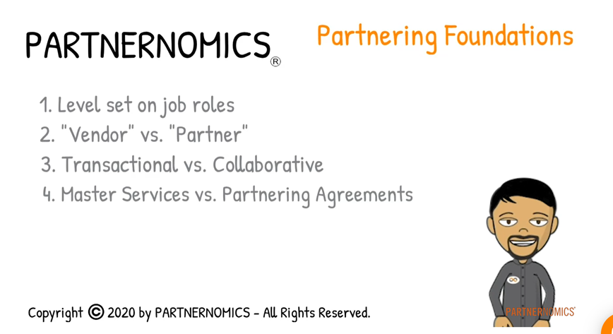 | 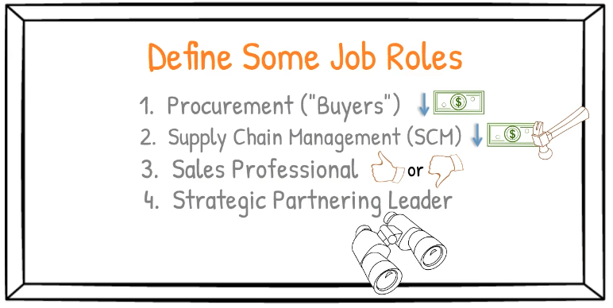
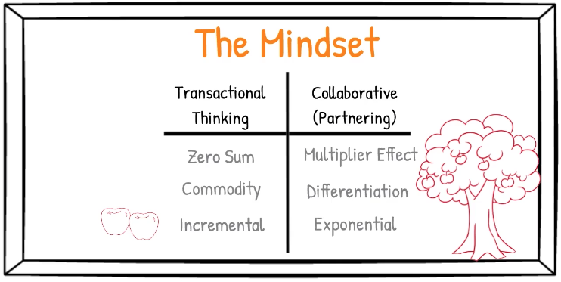 | 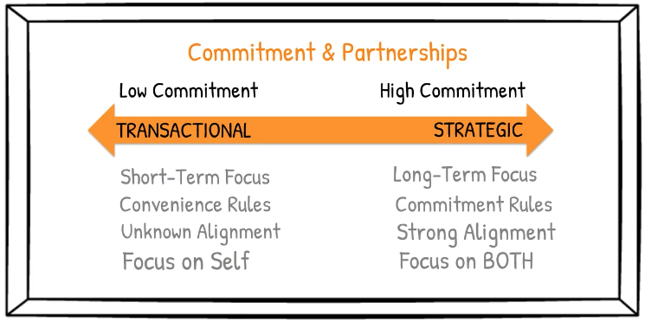

Notes:

WEEK #2

Week #2 Learning Objectives:
- Participants will know the quadrants of solutions and understand how companies can increase margins.
- Participants will gain a basic understanding of how innovation can impact supply & demand shifts within a market.
- Participants will be exposed to 12 opportunities to partner where value could be created for their organization.

Thought Leader Interview
David Klinkon - CloudMinds Executive

Questions to Consider:
- How is/might artificial intelligence (AI) and robotics technology impact your industry and organization?
- Do you believe that your organization is innovative and why, or why not?
- Do you believe innovation is critical for your organization’s future success?
- How good is your “partner recruiting pitch” and what could your organization do to improve your pitch?
- If you could dictate your organization’s future, how would it be different in 5 years?

Notes:

Topics in Video #3
- Birth of the iPhone
- Quadrants of Solutions
- Supply & Demand Refresh
- Goals for Partnering

Questions to Consider:
- Why did the Apple and AT&T partnership revolutionize the cell phone industry?
- Think of some innovative products. Which quadrant of solutions are they currently living in?
- What is your team’s greatest opportunity for a new “revenue growth” partnership?
- What is your team’s greatest opportunity for a new “cost reduction” partnership?
- How does your team manage strategic partnerships different from transactional partnerships?

Notes:

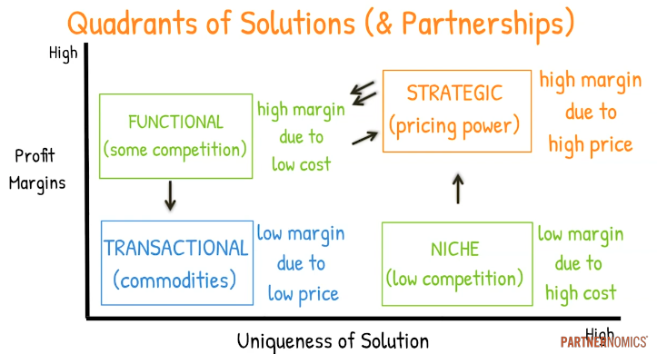 | 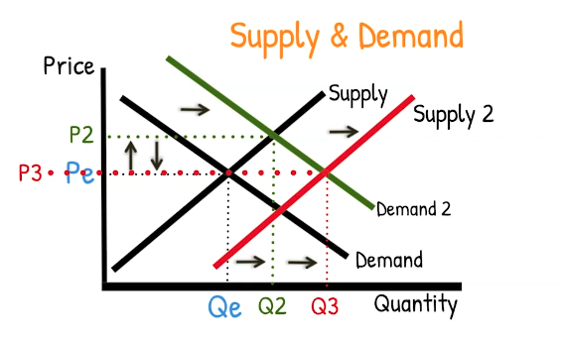

Notes:

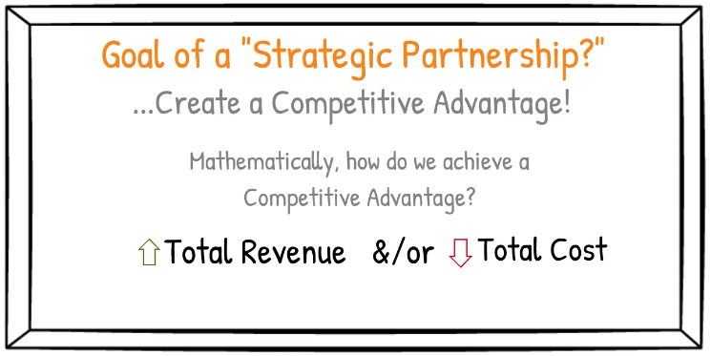

Notes:

Topics in Videos #4 & 4b
- Bernie Brenner - Sumo Advantage
- Steve Case - The Third Wave
- 12 Opportunities to Partner

Questions to Consider:
- What challenges do small organizations face when partnering with large companies?
- How can strategies accelerate success with such partnerships?
- Sales is about getting a “YES.” What’s the focus for business development / strategic partnering? How have you experienced this topic in your career?
- Think of a conflict circumstance with one of your partners at some point in your partnering career. Was the situation handled in a constructive or destructive way?
- If “The Third Wave” is leveraging the Internet, what are some new ways your organization can better leverage the Internet to create value?
- Which of the 12 opportunities for partnerships best fits a need in your organization right now?

Notes:

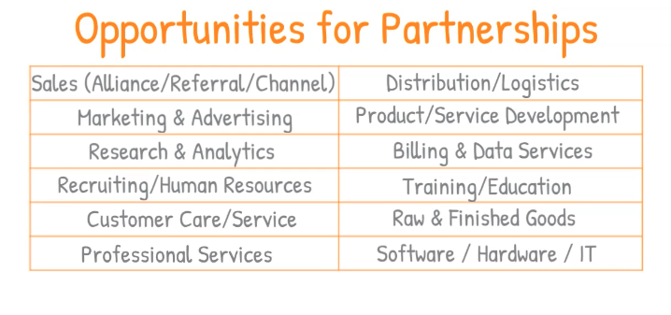
Notes:

WEEK #3

Week #3 Learning Objectives:
- Participants will be able to articulate Dr. Paul Zak’s 8 Trust Factors.
- Participants will be able to describe the 5 types of partnerships.
- Participants will become familiar with examples of each type of partnership.
- Participants will be able to describe the 5 imperatives for partnership success (Partnership Success Pyramid).

Thought Leader Interview
Dr. Paul Zak - Trust Factor

Questions to Consider:
- How does trust predict rich or poor economies in countries all over the world?
- Do others perceive you as a threat or as a potential collaborator?
- Why do I need to be trusting in order to be trusted?
- How does emotional intelligence (EQ) affect trust and (eventually) performance?
- What are some ways that you intentionally build trust (8 Trust Factors)?

Notes:

Topics in Video #5
5 Types of Partnerships
- Alliance/Affiliate
- Referral/Matchmaker
- Channel/Reseller
- Resource/Capital
- Integrated/Technology

Questions to Consider:
- Which of the 5 types of partnerships is most common for your organization?
- Which of the 5 types of partnerships can your company most improve on?
Notes:

Notes:

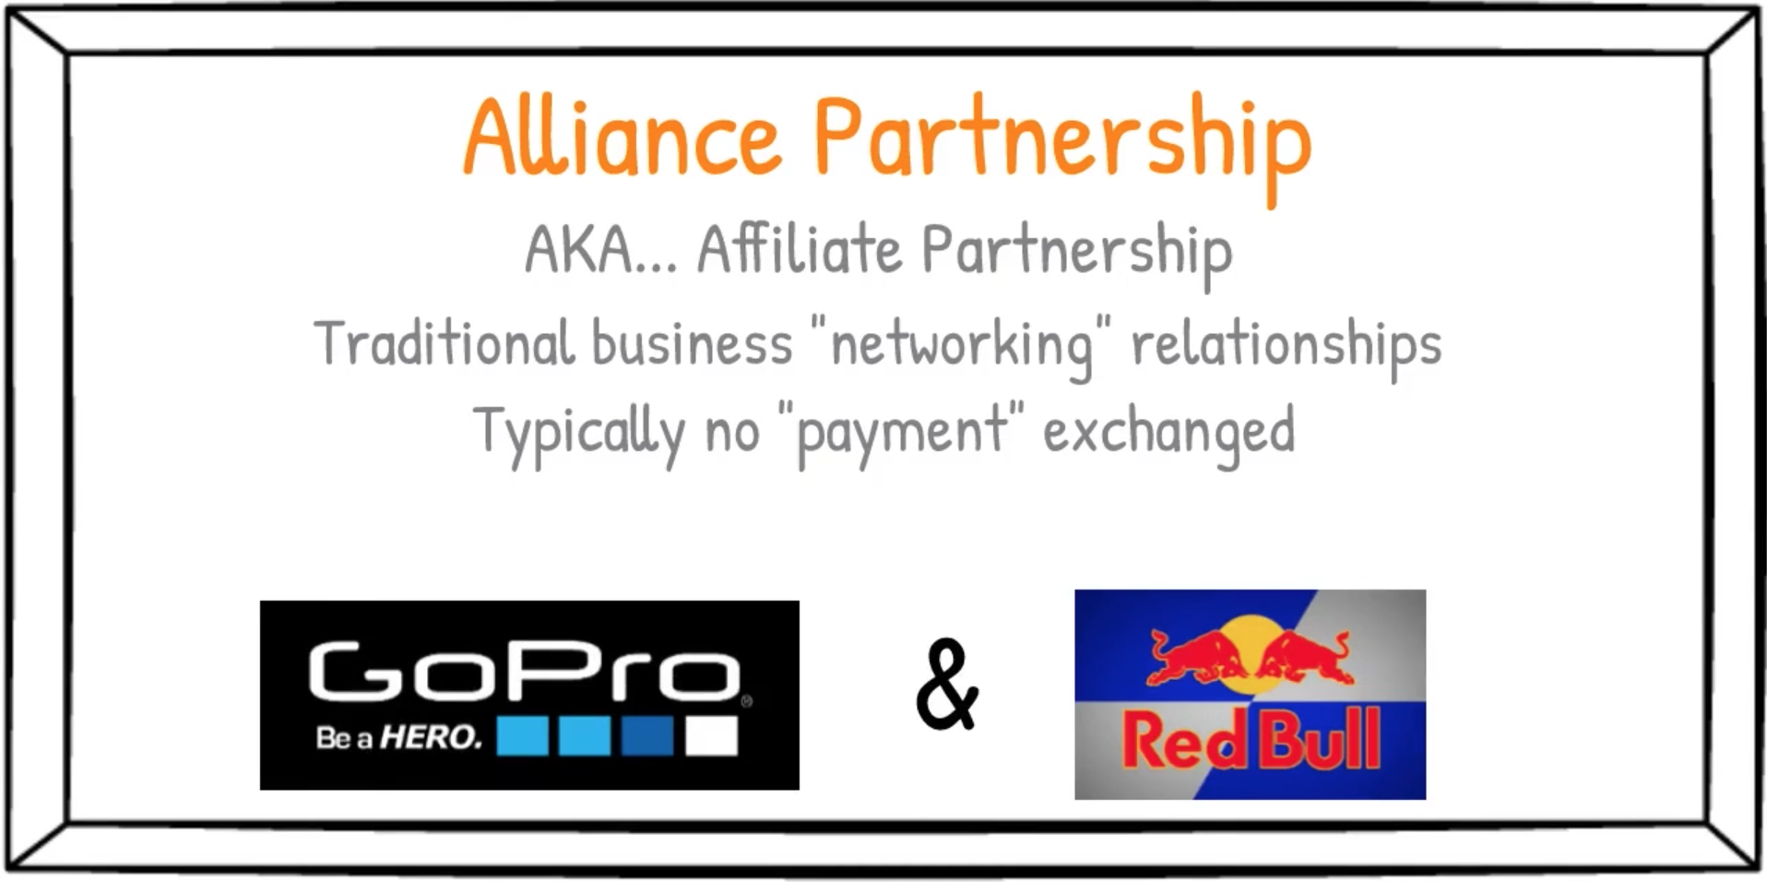 | 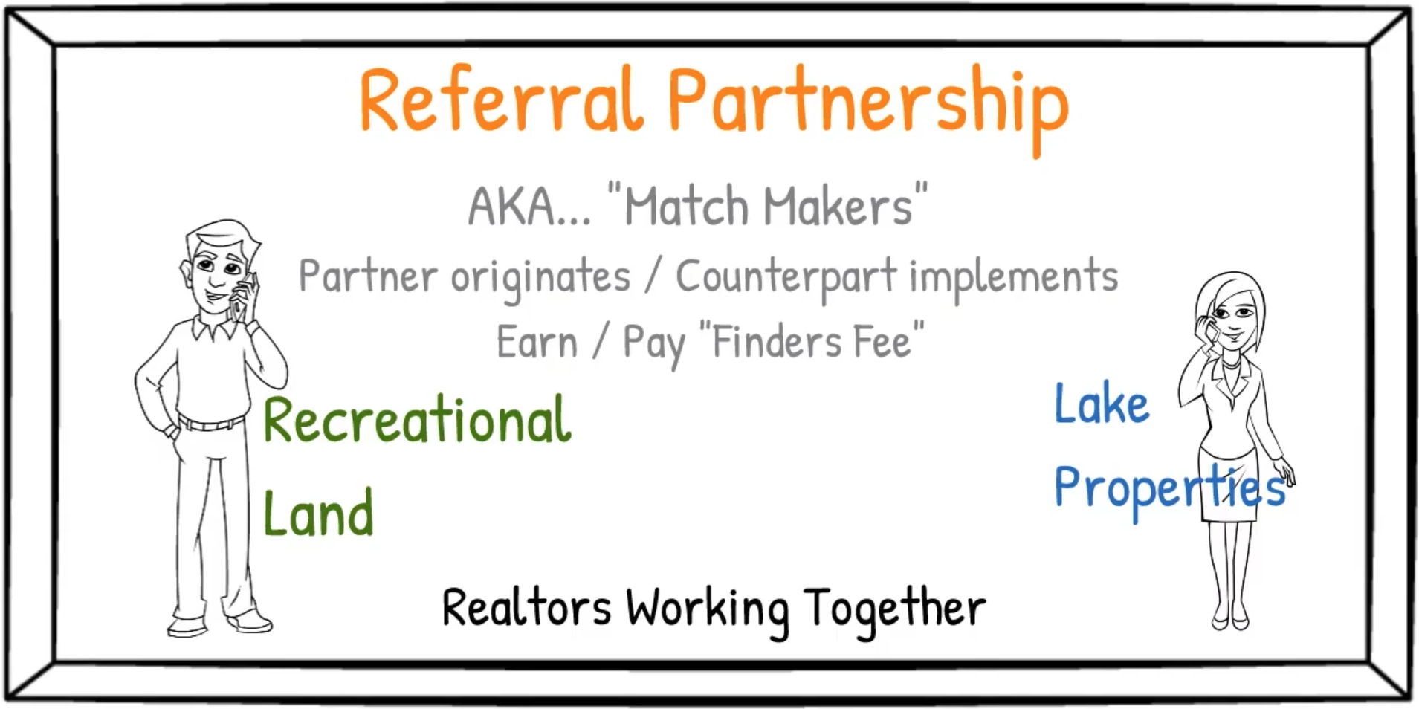 | 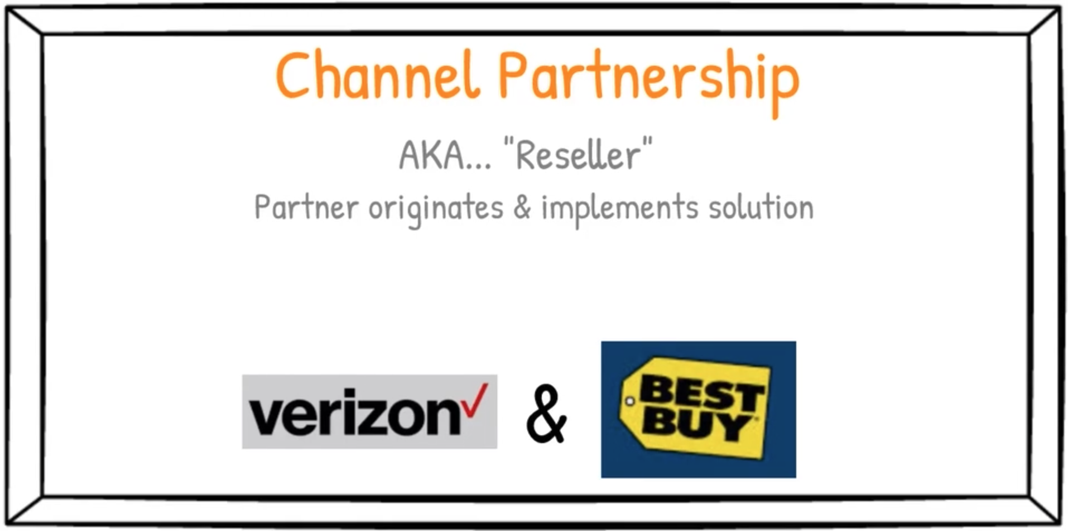

Notes:

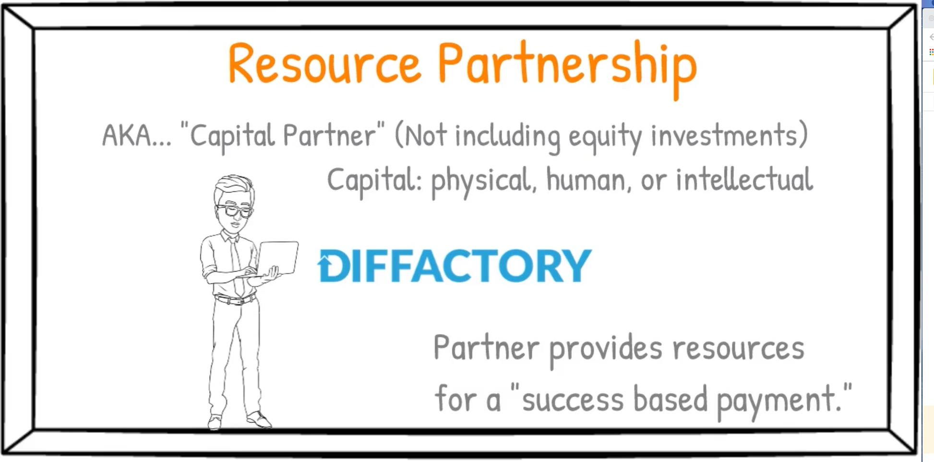 | 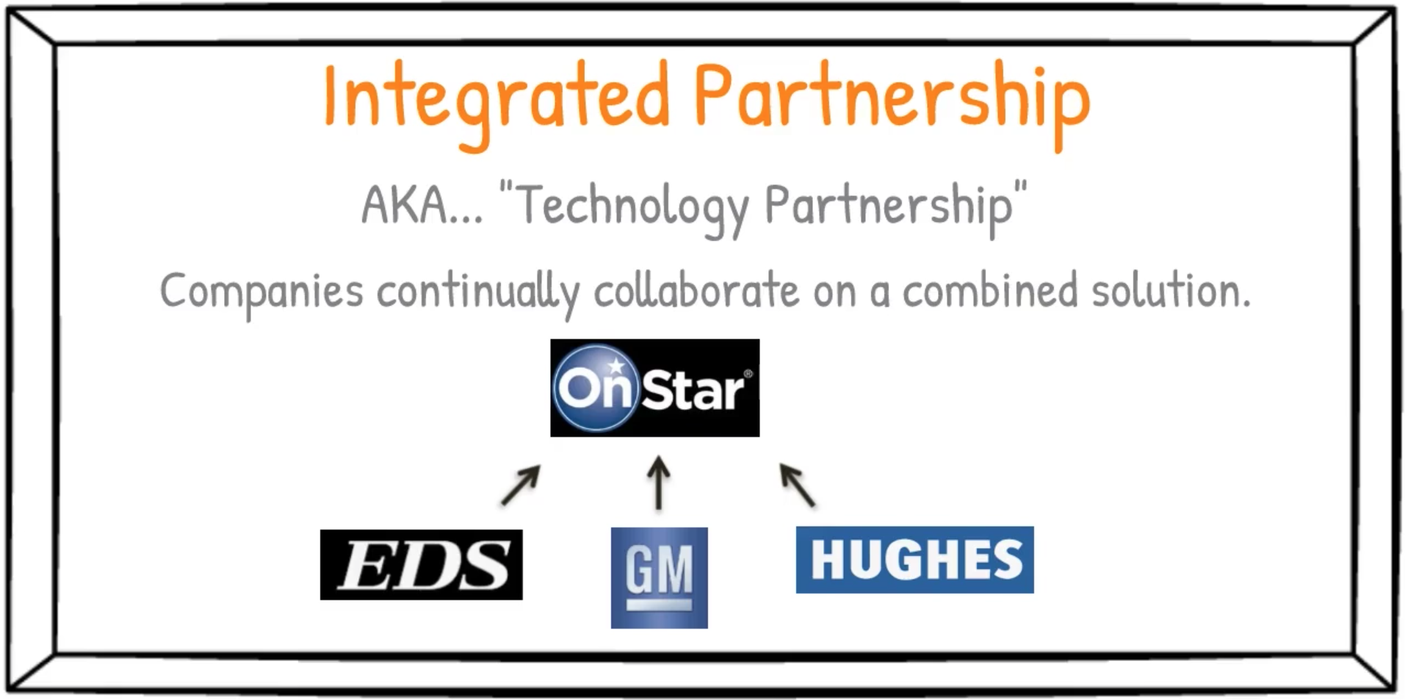

Notes:

Topics in Video #6
Partnership Success Pyramid
- Trust
- Alignment
- Transparency
- Esprit de Corps
- Results

Questions to Consider:
- What are some key reasons why 70% of partnerships fail (are not successful) in the first two years?
- Which of the imperatives of partnership success does your organization need to work on the most?
- How can you incorporate the Partnership Success Pyramid to guide your conversations with prospective partners?
- How do high levels of trust correlate with fast growth/performance?
- Does your organization and team have an explicit vision, mission, and core values identified?
- Do you believe in the philosophy of transparent communications, why or why not?
- Do you believe that your partners (new and old) have high levels of commitment to your organizational partnership? What could be done to improve commitment levels?

Notes:

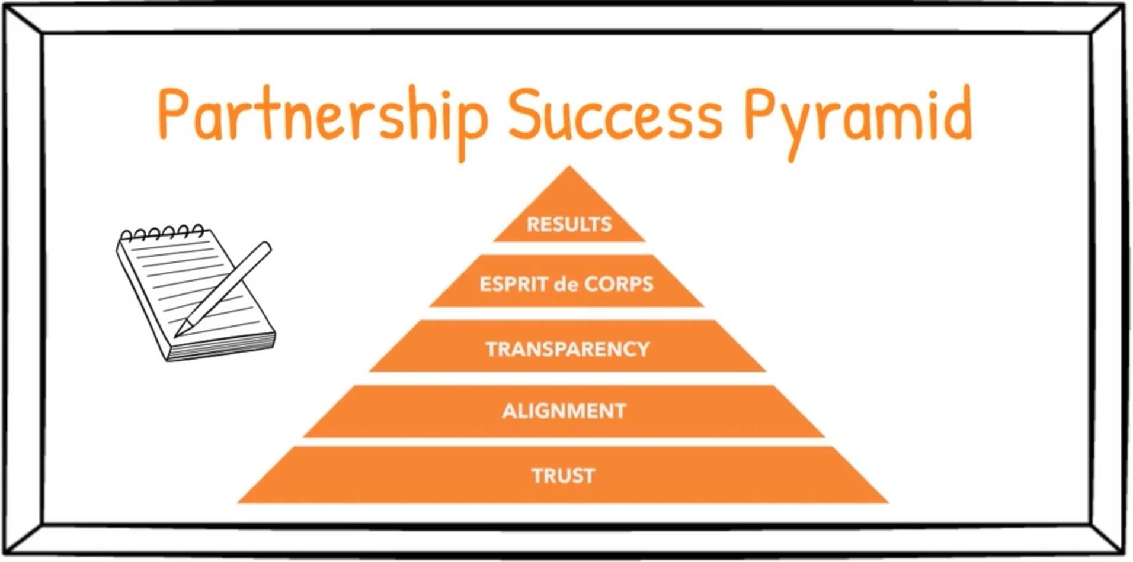

Notes:

WEEK #4

Week #4 Learning Objectives:
- Participants will learn why the 21st century economy is ripe for partnerships.
- Participants will learn how to conduct a basic Power Analysis.
- Participants will learn the critical differences between Needs vs. Wants and how each impacts partnerships.
- Participants will learn how to conduct a SWOT analysis and how the results of this analysis can inform opportunities for new partnerships.

Thought Leader Interview
Danny O’Neill - The Roasterie

Questions to Consider:
- Danny mentions having a vision for which company or capability may become his company’s greatest competitor. What company or capability will most likely be your organization’s greatest competitor? Is it an industry rival or an unassuming technology startup?
- Why is there such a struggle for new companies to become sustainable? How can partnerships create a paradigm shift with this topic?
Notes:

Topics in Video #7 & 7b
- Technology is Causing Change
- Market Statistics
- Be Solutions Focused, not Product Focused

Questions to Consider:
- How is technology changing your industry and organization? What opportunities are being created by new technologies for your industry?
- Why has the lifespan of companies significantly decreased over the past century?
- What is the root reason Borders, Blockbuster, and Kodak filed for bankruptcy?
- What is your customer's "job-to-be-done?" What part(s) of that job is your organization delivering? How might that job expand in the future?

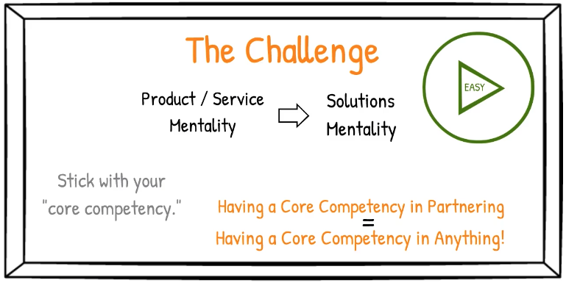

Notes:

Topics in Videos #8, #8b & #8c
- Power Analysis
- Needs vs Wants
- SWOT Analysis

Questions to Consider:
- Do you conduct a Power Analysis when engaging a partner candidate?
- What are your company's greatest points of "power?"
- Do you clearly identify and segment your "needs" and "wants" before negotiations?
- What are your organization's greatest "Strengths" and "Weaknesses" now?
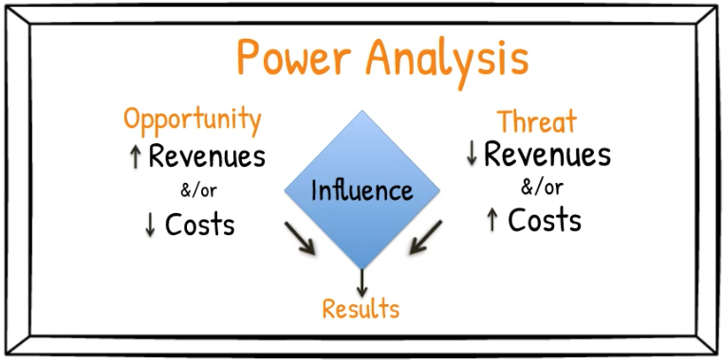
Notes:

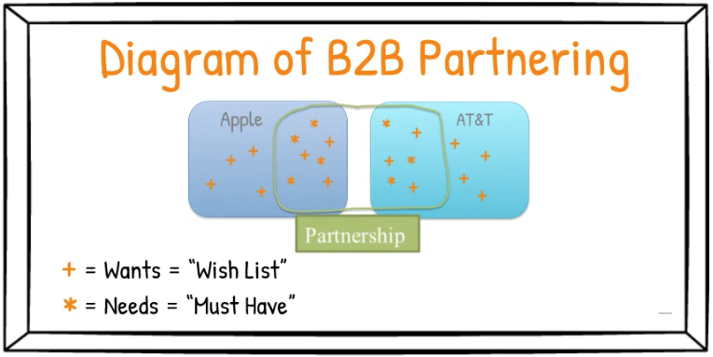

Notes:

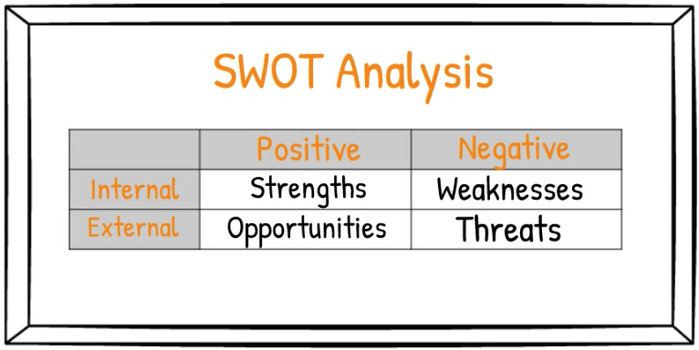

Notes:

WEEK #5

Week #5 Learning Objectives:
- Participants will understand the Business Growth Flowchart and how it can be used to facilitate organizational growth strategy conversations.
- Participants will understand the difference between incremental and exponential growth strategies.
- Participants will be able to articulate the basic premise of the Theory of Constraints and identify bottlenecks in their organization.
- Participants will be able to articulate the basic premise of the 6-Cs framework and identify potential opportunities to partner based on this analysis.
- Participants will be able to describe the pros and cons of the three approaches to organizational growth: organic, acquisition, and partnering

Thought Leader Interviews

Bernie Brenner, CEO of Rollick
Jason Nierman, VP of Business Development, Rollick

Questions to Consider:
- What was your greatest takeaway from this Bernie Brenner (Rollick) video?
- Why did Bernie decide to acquire AVALA Marketing vs partnering and do you agree with his rationale?
- What’s the difference between being “EBITDA focused” vs “growth focused” and how are they managed differently?
- How does innovation play a role in further developing an organization?

Notes:

Topics in Videos #9 & #9b
- Business Growth Flowchart
- Incremental vs Exponential Growth
- Research Phase
  - SWOT Analysis
  - Constraints Model
  - 6-Cs Framework

Questions to Consider:
- Does your organization have a holistic “strategic plan” that covers the next 12-24 months? If yes, is it clear in your mind?
- Is your organization committed to “exponential” growth right now? If yes, what is your most strategic “growth engine?”
- In the “Research Phase” we recommend using a “SWOT Analysis,” “Constraints Model,” and the “6-Cs Framework.” Does your organization use these three frameworks? How could your organization adopt (better use) these tools?
- What is your organization’s greatest bottleneck (Constraints Model)?
- With respect to the 6-Cs framework, what are your organization’s best opportunities to partner?
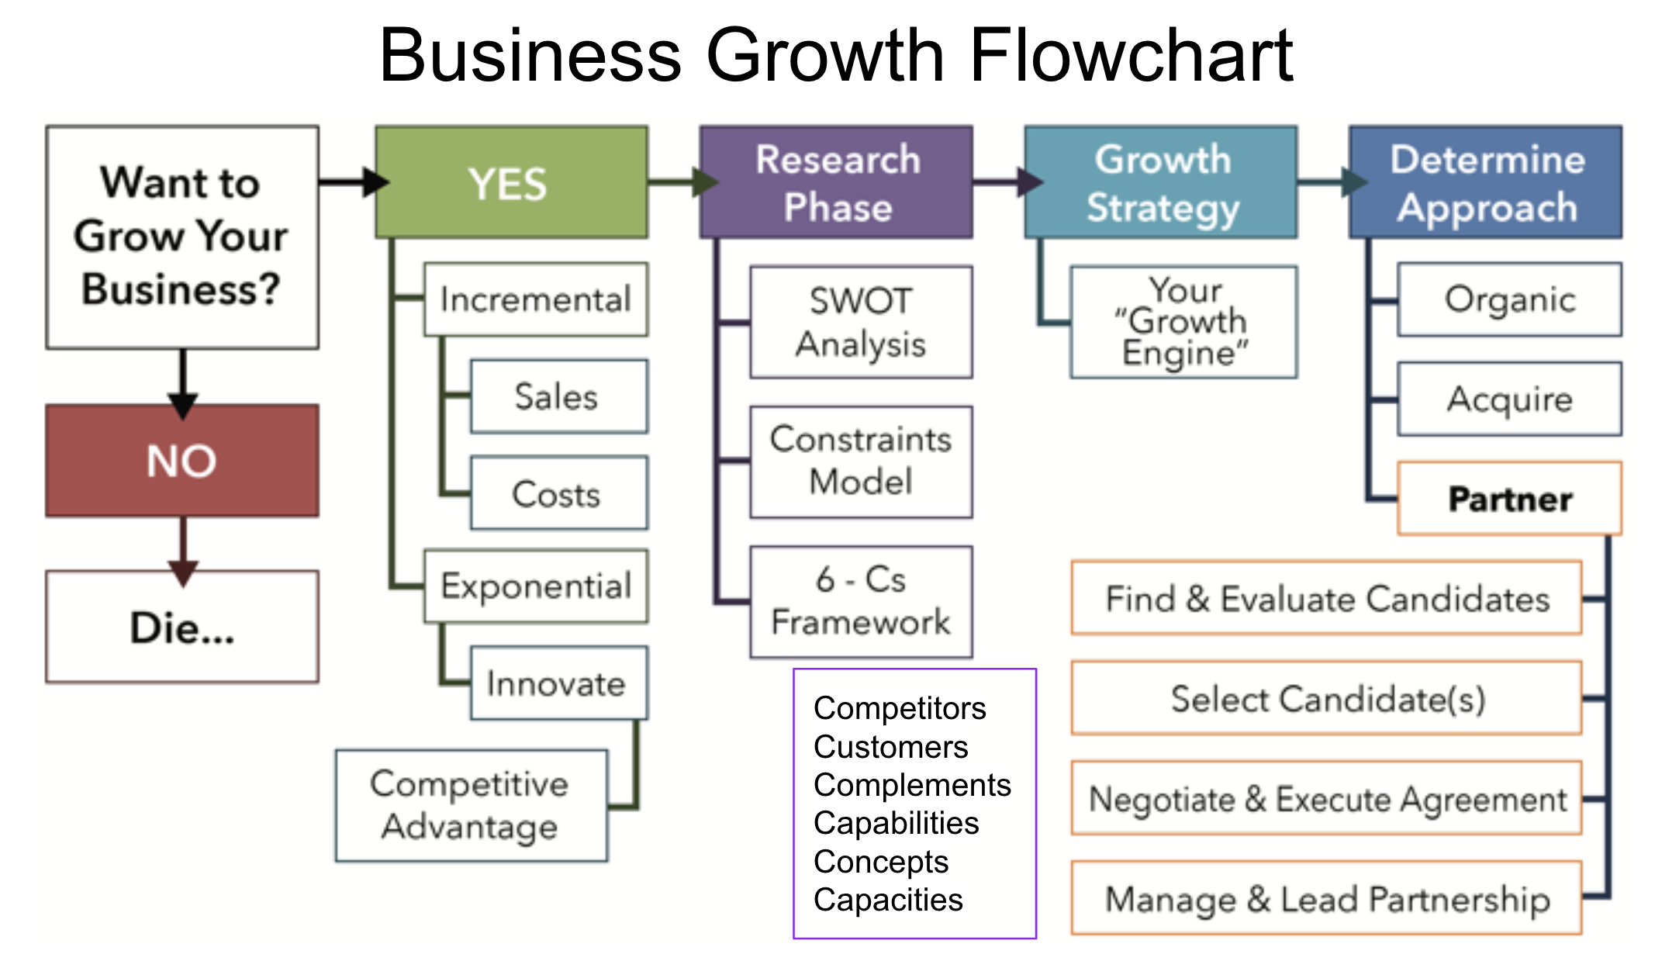

Notes:

Topics in Video #10a & #10b
Pros/Cons of:
- Organic
- Acquisition
- Partnering

Questions to Consider:
- What were your major takeaways from the Pros/Cons of the three avenues for growth (organic, acquisition, partnering)?
- When considering an avenue for growth does your organization consider “cross-pollination” as a potential benefit of working with other organizations?
- Regarding the pros/cons of partnering, for which of the characteristics do you feel your company lacks consideration?
Notes:

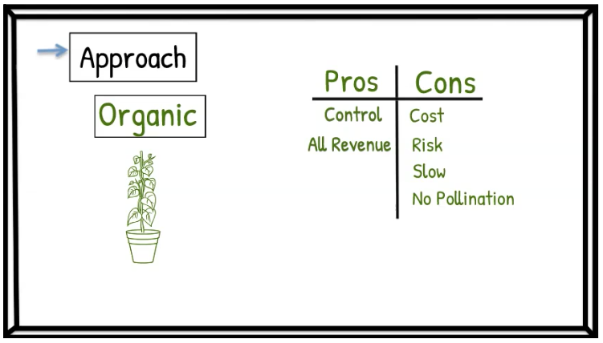
Notes:

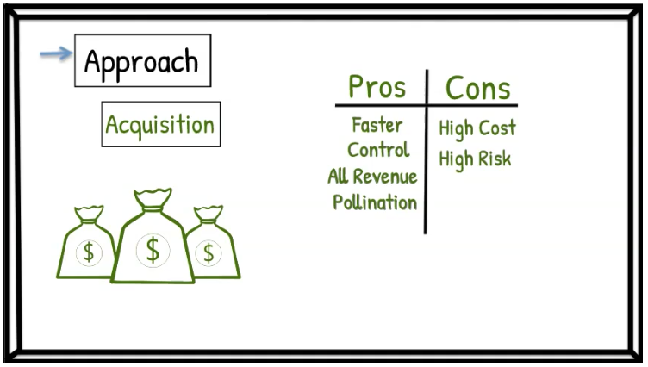
Notes:

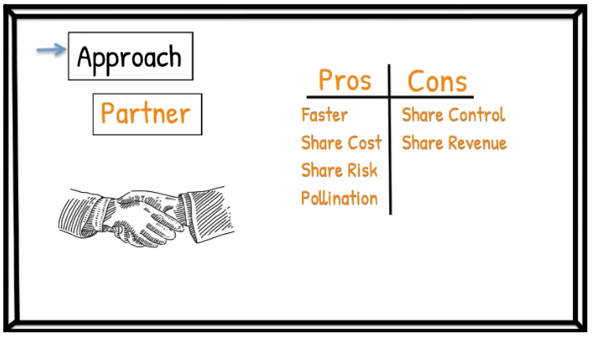
Notes:

WEEK #6

Week #6 Learning Objectives:
- Participants will understand the concept of a “growth engine.”
- Participants will learn how Branch chose and executed a growth strategy using its growth engine, Instant Pay.

Thought Leader Interviews
Atif Siddiqi, CEO of Branch
Greg Unruh, Strategic Partnering Consultant

Questions to Consider:
- What was your greatest takeaway from Atif Siddiqi’s video?
- Do you agree with Atif’s answer as to why a partnering approach can be more efficient than organic?
- Why do you think Branch’s partnering strategy was a success thus far?
- Did Branch try to create a Sumo Advantage?

Notes:

Topics in Video #11
Growth Engine
- Branch / Instant Pay

Questions to Consider:

- Are your organization’s solutions being commoditized (downward pressure on price)? If yes, how can this be addressed?
- What opportunities exist for your organization to innovate?
- What are your customers' most attractive “jobs-to-be-done?” How can your organization take an “ecosystem approach” and create a more holistic solution?

Notes:

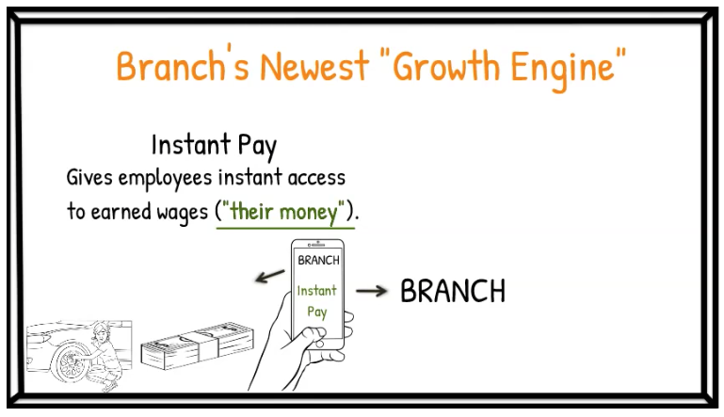

Notes:

