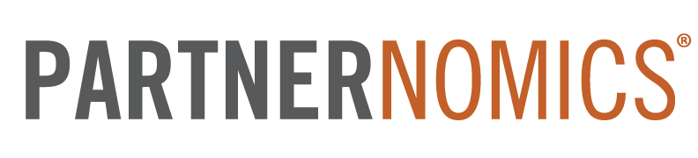
COURSES WORKBOOK

5 Phase Partnering Process (5PPP)

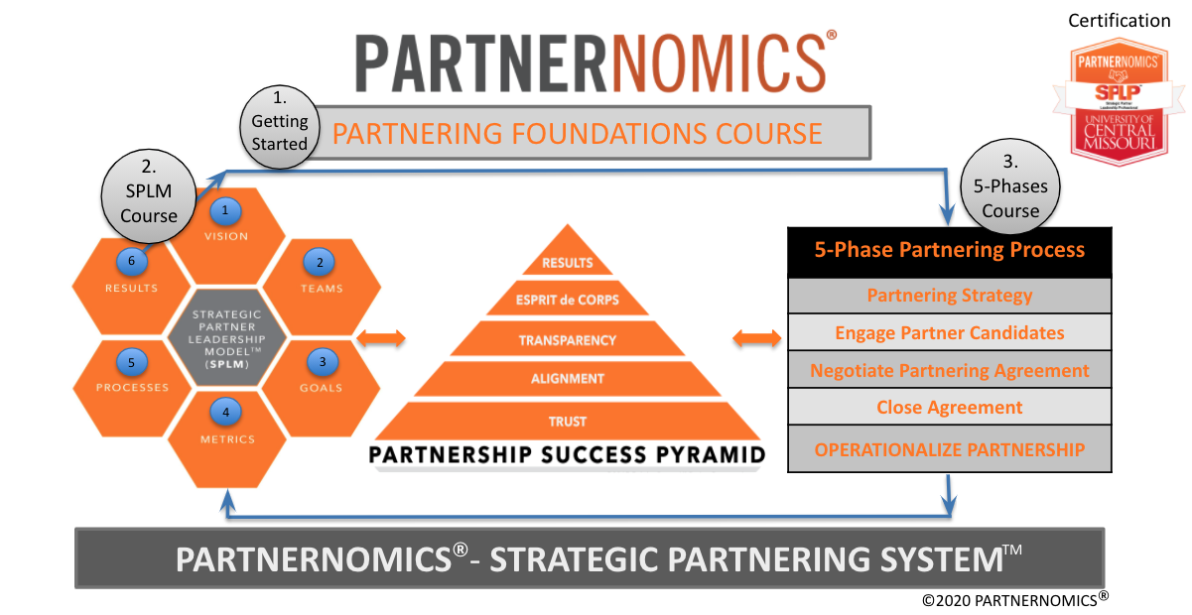
5-PHASE PARTNERING PROCESS (5PPP)

Course Description:
The PARTNERNOMICS – 5-Phase Partnering Process course is designed for the business professional who is interested in taking a deep dive into the “pre-contract signature” processes to understand the optimal way to construct partnership agreements, perform due diligence, and negotiate agreements that deliver results. This course teaches the following five phases with an emphasis on the first four:

- Building a Strategic Partnering Plan
- Engaging Partner Candidates
- Bargaining/Negotiating the Agreement
- Closing the Agreement
- Operationalizing the Partnership

Participants will be introduced to several concepts, tools, and strategies that will help them more effectively manage and execute each phase. The course contains over 6 hours of video content. Approximately half of the videos are topical lessons that explain key concepts and tools, while the remaining videos include expert interviews with international partnering and business growth thought-leaders.
An underlying purpose of this course is to teach tools and techniques that will accelerate the speed to execute partnership agreements. By using proven tools and a disciplined process to ideate, negotiate, and architect agreements, participants can reduce the cycle times by at least 50%.

Course Learning Objectives:
- Construct a 12 component Strategic Partnering Plan using the SWOT analysis as a primary foundation.
- Describe the six components of the Partner Preparation Sheet and describe the value this tool brings to the Engage Phase.
- Articulate the 6 Engagement Skills and describe how each skill makes for more effective conversations.
- Conduct a basic Power Analysis with a potential partner.
- Articulate the 12 Negotiation Principles and describe how each can add value to partnership negotiations.
- Describe the 8 components of a Term Sheet and articulate the success practices associated with utilizing a Term Sheet.
- Utilize the Candidate Scoring Tool, articulate the 10 Standard Criteria, and suggest additional criteria based on your team and typical partners.
- Articulate the meaning of standard “business terms” and “legal terms” commonly found in partnering agreements.

WEEK #1

Week #1 Learning Objectives:
- Be able to articulate the 12 components of the Strategic Partnering Plan
- Effectively identify the Problem and Purpose of a specific partnering initiative
- Conduct a SWOT (Strengths, Weaknesses, Opportunities, Threats) Analysis for a unique partnering initiative.
- Effectively conduct a Risk Analysis for a proposed partnering initiative.
- Effectively set Goals for a partnering initiative using the PARTNERNOMICS methodology.

Thought Leader Interview

Jay McBain, Principal Analyst, Forrester Research

Questions to Consider:
- Seventy-five percent of world commerce is conducted through partnerships. What percentage of your annual revenue comes from partnerships?
- 76% of CEOs say their business model will be unrecognizable in 5 years. How will your organization’s business model change in the near future?
- Marketplaces, such as Amazon have grown more in the last 3 months than they had in the past 10 years. Can you leverage a digital marketplace to sell your solution(s)?
- “The average quantity of partnerships being managed by an organization needs to grow by 10 times over the next 3-5 years in order to compete.” What is your company doing to be able to effectively evaluate and execute 10x its current partners?

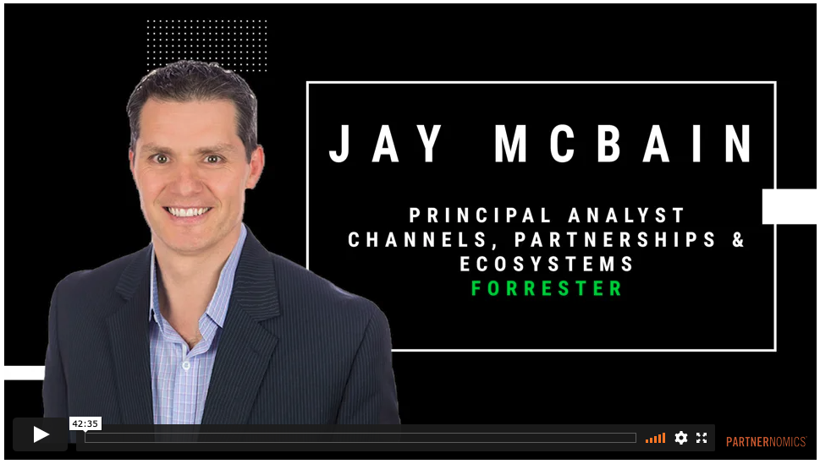

Notes:

Topic Video - 5PPP - Video 1
- Overview of the 5 Phase Partnering Process course

Questions to Consider:
- What tools does your team currently use when executing partnerships?
- Which of the tools presented are new concepts to you/your team?
- Given the 5 phases of the partnering process (below) which phase do you feel your team manages the best and which could use the most improvement?
  - Build a Partnering Strategy
  - Engage Partner Candidates
  - Bargain/Negotiate an Agreement
  - Close Agreement (Go/No Go Decision)
  - Operationalize Partnership

Notes:

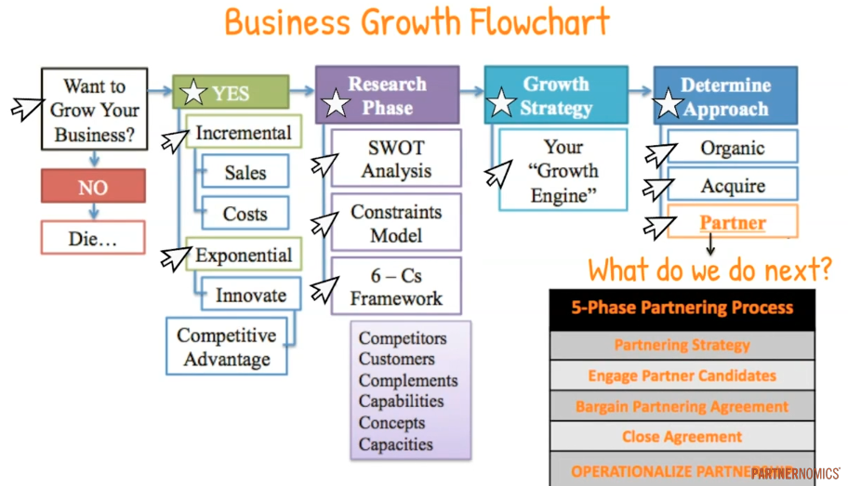
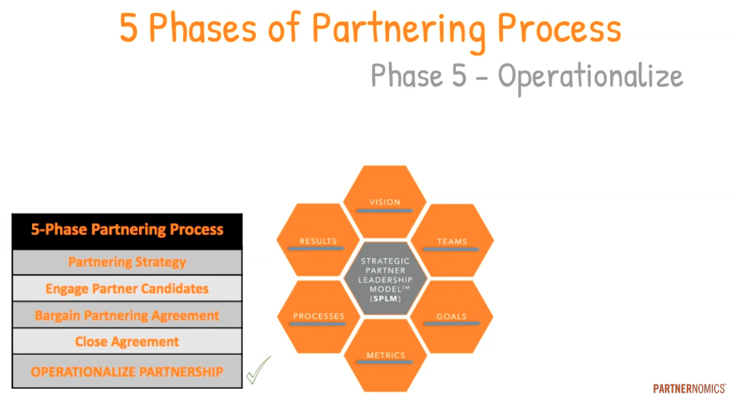

Notes:

Topic Video - 5PPP Video 2

- Introduction to Phase 1 - Building a Partnering Strategy
- The 12 components of the Strategic Partnering Plan (SPP)

Questions to Consider:
- Does your team write explicit and standardized partnering plans for each partnering initiative (co-marketing, co-development, referral, technology, channel sales, etc.), before engaging potential partners?
- When considering the 12 components of the SPP, what areas do you feel your team performs well in addressing? Which areas could be improved?
- If your team uses a standardized partnering plan, what are the key differences between your template and the PARTNERNOMICS SPP?
- If your team does not use a standardized partnering plan, what are the greatest benefits that could come from adopting the PARTNERNOMICS SPP approach?
Strategic Partnering Plan (SPP) - 12 Components

Component #1:
Component #2:
Component #3:
Component #4:
Component #5:
Component #6:
Component #7:
Component #8:
Component #9:
Component #10:
Component #11:
Component #12:

Notes:

WEEK #2

Week #2 Learning Objectives:
- Partner Preparation Sheet (6)
- Non-Disclosure Agreement
- Partnership Success Pyramid
- The 6 Engagement Skills
- Effectively Asking Questions
- Using a Power Analysis

Thought Leader Interview

Robin Dreeke, People Formula - Interpersonal Communications Expert

Questions to Consider:
- What was your key takeaway from the interview with Robin Dreeke?
- Robin shares four success practices for engaging others in interpersonal communications. He says we should, “Seek the thoughts and opinions of others.”
“Talk in terms of other’s priorities.” “Validate others without judging them.” and “Give people choices.” Of these four practices, of which are you best and worst?
- Robin said, “People that try to hide a weakness are the least trustworthy.” Do you agree with this statement? How does this concept play out in partnerships?
- Towards the end of our discussion, Robin spoke about the three “relationship accelerators” (proximity, intensity, duration). Do you consider accelerators when forming and nurturing relationships?

Notes:

Topic Video - 5PPP Video 3

- Intro to Phase 2 - Engage Partner Candidates
- 6 Good Engage Skills
- Partner Preparation Sheet

Questions to Consider:
- When considering the six “Good Engage Skills,” which skill(s) are you above average and which are you below average?
- Thinking back on previous conversations with prospective partners, does your team take the time to understand their needs & expectations before you communicate your desired needs?
- There is an art to asking questions (open-ended / closed-ended). How can you become more effective at questioning when working with new partner candidates?
- Do you follow and share a standard meeting agenda form with your prospective partners? What value could/does this successful practice offer?
- Does your team follow a standardized partner meeting tool, such as the Partner Preparation Sheet? What value may be realized by adding this tool to your process?

Notes:

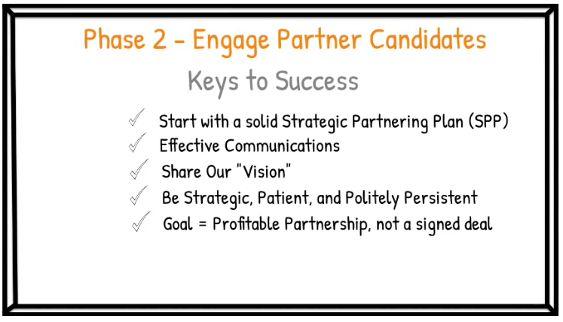

Notes:

The 6 “Good Engage Skills”

Skill #1:
Skill #2:
Skill #3:
Skill #4:
Skill #5:
Skill #6:

Partner Preparation Sheet
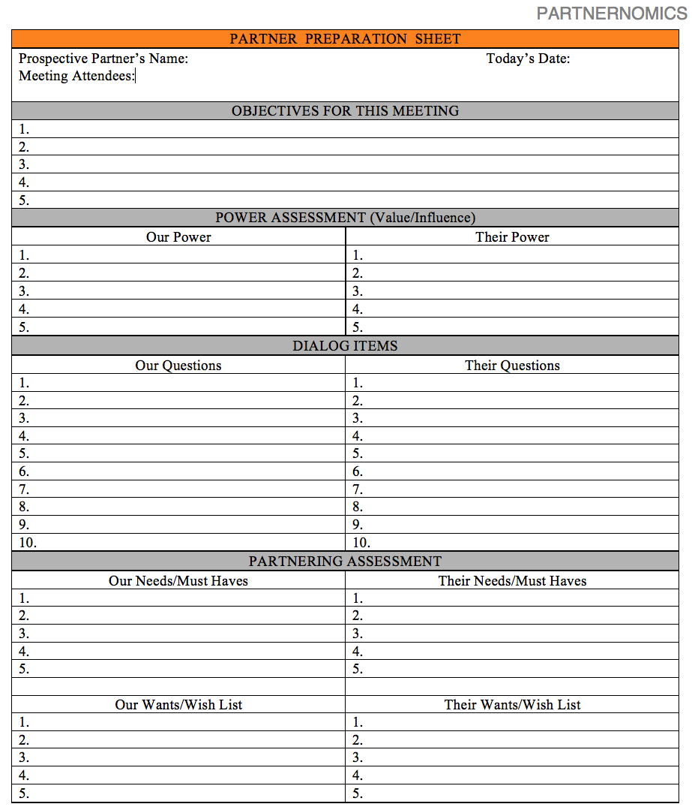

Notes:

Topic Video - 5PPP Video 4

- Introduction to Phase 3 - Bargain/Negotiate Terms
- Key Concepts in Bargaining
- 4 Items of Homework
- Bargaining Matrix

Questions to Consider:
- What was your major takeaway from this topical video?
- How well do you “wear all three hats” when bargaining your agreements, today (Leader, Summarizer, Observer)?
- How can you better use ‘signals’ to get better outcomes in your conversations?
- When making an offer, how does using the framework of, “If you… then I will...” impact an agreement?
- What is meant by, “You can’t unring a bell.”?
- Is it your team’s standard practice to build a “Bargaining Matrix” before each negotiation?
  - [Must Have <> Bargaining Zone <> Nice to Have]
- Why should you ALWAYS create and use a “wishlist” when bargaining?

Notes:

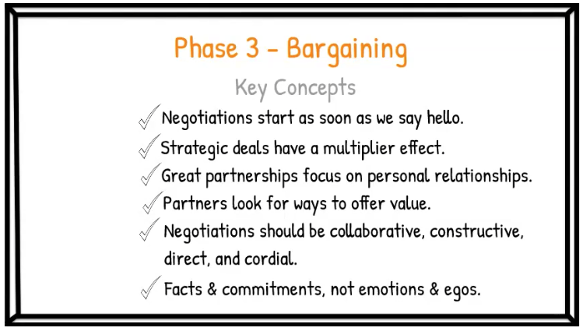

Notes:

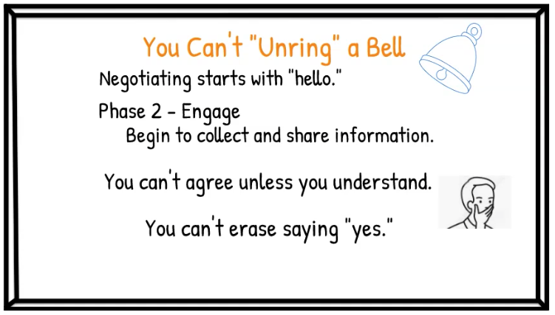 | 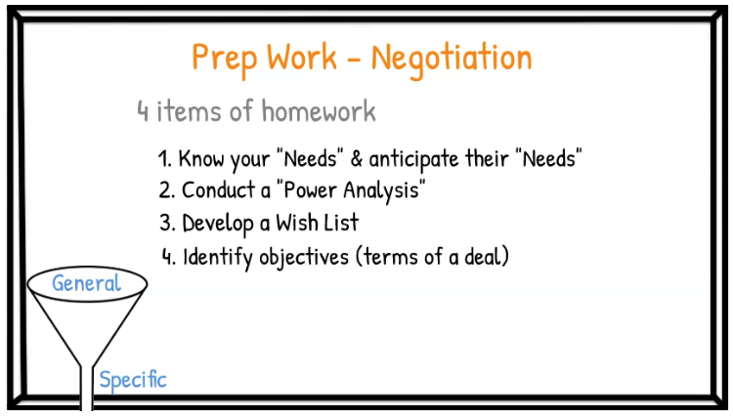
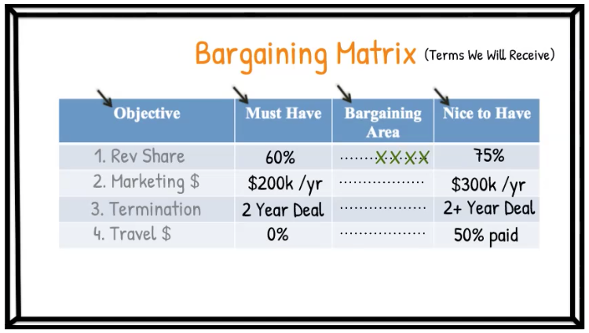

Notes:

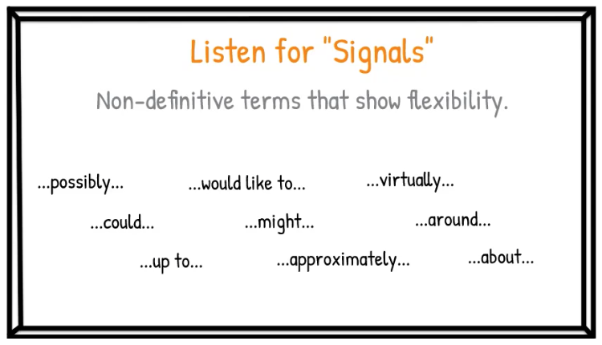

Notes:

Statistically speaking, what is true about situations when your counterpart says, “Make me an offer?”

Notes:

What is a “conditional offer?” Share an example.

Notes:

What are the 5 items you should consider when receiving an offer?

Item #1:
Item #2:
Item #3:
Item #4:
Item #5:

Should you ever split the difference, why or why not?

Notes:

WEEK #3

Week #3 Learning Objectives:
- Describe the success practices for contracts management
- Articulate the “3 Tasks” to initialize a new partnership.
- Describe the 8 components of the Term Sheet.
- Explain the various components of the Candidate Scoring Tool and describe the value it brings to the partnering process.

Thought Leader Interview

Bernie Brenner – CEO of Rollick

Questions to Consider:
- What was your greatest takeaway from this conversation with Bernie Brenner?
- Given Bernie’s insights, how might you better evaluate your partner candidates in the future (to improve the likelihood of long-term success)?
- How can you modify your Term Sheet process to streamline your “get to yes/no” decision with partner candidates?
- Does your team and partners generally view conflict as a negative and avoid it? Or, do they see differences in opinion as a way to challenge the status quo and an opportunity to take relationships and joint solutions to a higher level?

Topic Video - 5PPP Video 5

- Introduction to Phase 4 - Close Agreement
- Introduction to Phase 5 - Operationalize Agreement

Questions to Consider:
- What system does your company have in place to keep records of all contracts and other key documents?
- What are the initial steps to launching the management of the new partnership (so you maintain momentum)?

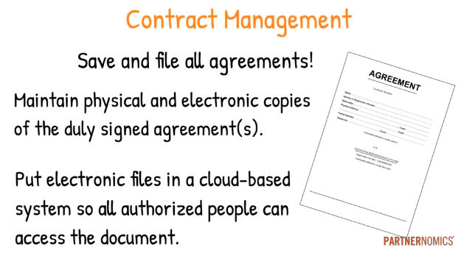

Describe your company's contracts management process? Do you have a standard way to save both physical and electronic copies of agreements?

Notes:

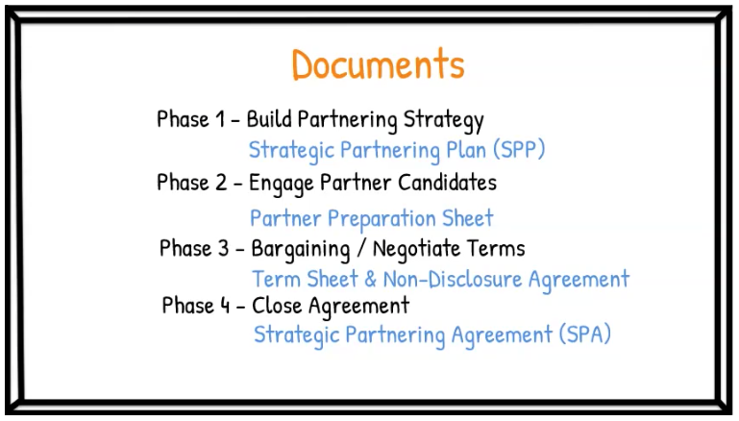

Describe how your team manages and shares documents, such as Strategic Partnering Plans, Term Sheets, and Candidate Scoring Tools with each other. How can sharing capabilities be made better?

Notes:

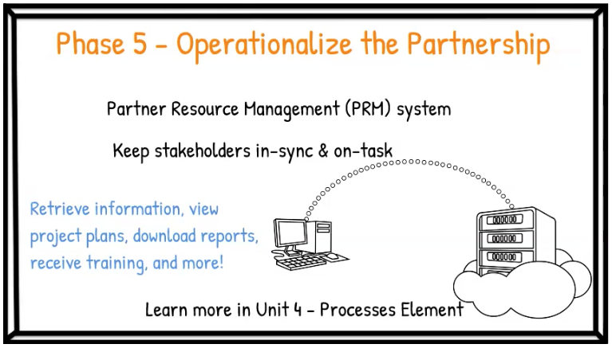

In what ways does (could) a Partner Relationship Management (PRM) system help your team manage the contracting process?

Notes:

What are the first “3 Tasks” to be completed as you start to operationalize a new agreement?

Task #1:
Task #2:
Task #3:

Notes:

Topic Video - 5PPP Video 6

- Non-Disclosure Agreement
- Term Sheet

Questions to Consider:
- What is your organization’s philosophy on the use of a Non-Disclosure Agreeent (NDA)? What percentage of your deals include the execution of an NDA prior to executing the full partnering agreement?
- Does your organization have a formal Term Sheet template that all partnering team members use?
- Does your team have a Term Sheet process that everyone follows?
- Is it a standard practice to negotiate all of the “business terms” from a Term Sheet and then include your legal support to construct and finalize the full partnering agreement?
- In what ways could your team better leverage Term Sheets to accelerate your negotiation and contracting process(es)?

Notes:

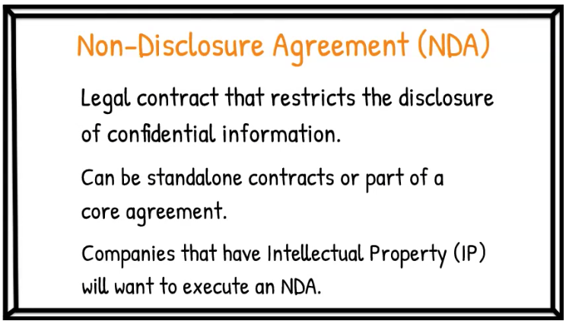

Notes:

What are 8 components of the Term Sheet?

Component #1:
Component #2:
Component #3:
Component #4:
Component #5:
Component #6:
Component #7:
Component #8:

Compare and contract your team’s Term Sheet and Term Sheet process to what is recommended in the PARTNERNOMICS’ methodology.

Notes:

In what ways could your team better leverage Term Sheets to accelerate your negotiation and contracting process(es)?

Notes:

WEEK #4

Week #4 Learning Objectives:

- Articulate key success practices regarding the authoring of Partnering Agreements
  - Business Terms
  - Legal Terms
- Describe success practices for working with an attorney to construct and eventually execute partnership agreements.
- Articulate the 10 “standard criteria” for evaluating potential partners.
- Effectively utilize the Candidate Scoring Tool to rank potential partners based on quantitative due diligence factors.

Thought Leader Interview

Business Terms to Know video - Chris Turney & Charlie Hyland

Questions to Consider:

- How would you characterize your team’s relationship with the attorney(s) that you work with? How might those relationships be improved at your organization?
- How does your team approach “transactional contracts” (MSAs) versus “strategic contracts”?
- Why should we spend the time on the “front-end” to put a sound agreement in place as opposed to “fixing it” when situations arise?
- Are you a fan of “exclusivity?” What is your philosophy on the use of exclusivity?
- Are you a fan of “termination for convenience?” What is your philosophy on the use of termination for convenience?
- How well does your team administer the terms of your contracts (termination, termination notices, payments, non-compete, exclusivities, etc.)?

Notes:

Topic Video - 5PPP Video 7

- Candidate Scoring Methodology (10 Standard Criteria)
- Candidate Scoring Tool

Questions to Consider:
- What was your greatest takeaway from video #7?
- What process does your organization use to score prospective partners?
- How would you rate the effectiveness of your current scoring mechanism?
- What modifications can you make to your current scoring process to improve its effectiveness?
- Given your company, industry, and various partnering initiatives, what additional evaluation criteria might you include in your scoring process?

Notes:

What are 10 “Standard” Scoring Criteria?

Criteria #1:
Criteria #2:
Criteria #3:
Criteria #4:
Criteria #5:
Criteria #6:
Criteria #7:
Criteria #8:
Criteria #9:
Criteria #10:

Candidate Scoring Tool

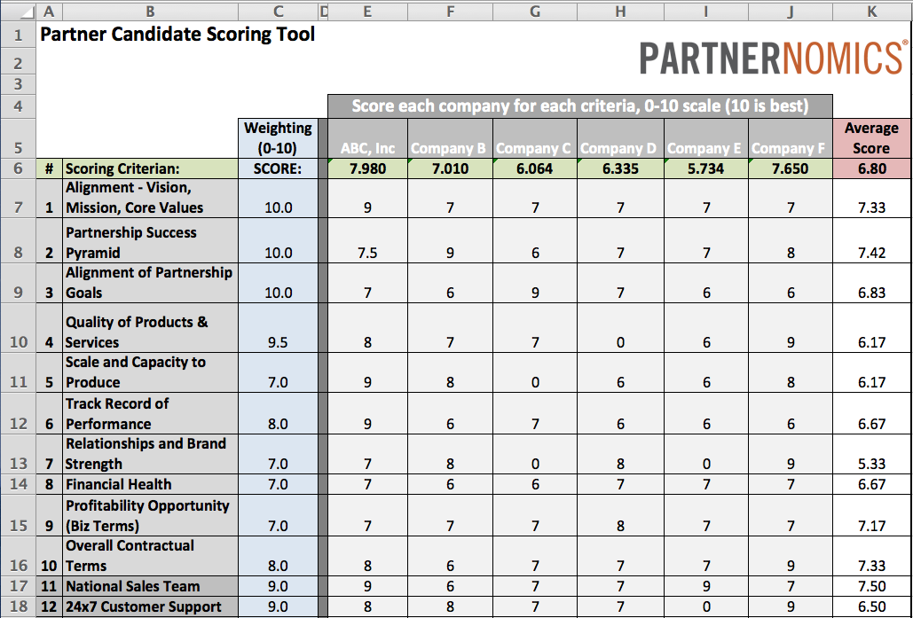

How might your team benefit by adopting the Candidate Scoring Tool?

Notes:

Topic Video - 5PPP Video 8

- Business Terms to Know

Questions to Consider:

- What was your greatest takeaway from Video #8?
- How would you rate your organization’s knowledge of these business terms?
- In terms of your team’s contracting process, do your team members author their own “business terms” in agreements (from templates) or does your attorney(s) author revisions to agreements?

Notes:

What are 12 “Business Terms” that are commonly found in partnering deals?

Term #1:
Term #2:
Term #3:
Term #4:
Term #5:
Term #6:
Term #7:
Term #8:
Term #9:
Term #10:
Term #11:
Term #12:

In what ways might your team improve its contracting proficiency by better understanding “business terms” that your organization typically encounters?

Notes:

WEEK #5

Week #5 Learning Objectives:
- Understand the Definitions of Core “Legal Terms” That are Frequently Contemplated in Partnering Agreements.
- Be Able to Articulate How to Sse or Explicitly Not Use Various “Legal Terms” in Negotiations and Written Agreements.

Thought Leader Interview

Legal Terms to Know video - Chris Turney & Shawn Stogsdill

Questions to Consider:

- What was your greatest takeaway from the “Legal Terms to Know” roundtable conversation?
- On a scale of 1-10, 10 being perfect, how do you rate the level of protection that your organization’s standard agreements currently provide?
- Which of the “legal terms” discussed in the video might you take a closer look at in your agreements, given what you learned?
- How can you use the insights gained from this roundtable conversation to improve your written agreements?

Notes:

Topic Video - 5PPP Video 9

- Working With an Attorney
- Agreements Will Mitigate Certain Risks
- Writing the Strategic Partnering Agreement (SPA)
- 10 Principles for Writing and Executing Agreements

Questions to Consider:
- How easy is it to “do business” with your legal counsel? How could this relationship(s)/process(es) be improved?
- On a scale of 1-10, 10 being perfect, how do you rate the level of protection that your organization’s standard agreements currently provide?
- How likely are you to follow the document sequence that PARTNERNOMICS recommends (Strategic Partnering Agreement, Partner Preparation Sheet, and Term Sheet)?

What are 10 Principles of Writing and Executing Agreements and how well does your team perform in these areas?

Principle #1:
Principle #2:
Principle #3:
Principle #4:
Principle #5:
Principle #6:
Principle #7:
Principle #8:
Principle #9:
Principle #10:

Notes:

WEEK #6

Week #6 Learning Objectives:
- Commitment to Execution
- Strategic Partner Leadership Professional®️ (SPLP®️) certification
- 7 Topics for Further Professional Development
- PARTNERNOMICS Executive Summary

Thought Leader Interview

Chris McChesney - 4 Disciplines of Execution

Questions to Consider:

- What was your key takeaway from the Chris McChesney interview?
- Which principles or insights are you most interested in applying to your partnering team/functions?
- Which parts of your current team management and partnering processes do you feel are already in alignment with the 4 Disciplines of Execution methodology?

Notes:

Topic Video - 5PPP Video 10

- Strategic Partner Leadership Professional®️ (SPLP®️) certification
- 7 Topics for Further Professional Development
- Executive Summary of Partnering Foundations
- Executive Summary of Strategic Partner Leadership Model - Part 1
- Executive Summary of 5 Phase Partnering Process
- Executive Summary of Strategic Partner Leadership Model - Part 2

Questions to Consider:
- What value would the SPLP®️ certification provide to you and your team members?
- Of the 7 Professional Development topic areas identified, which subjects could you benefit from the most?
- What is your next step when it comes to further implementing the PARTNERNOMICS methodology at your organization?

Notes:

